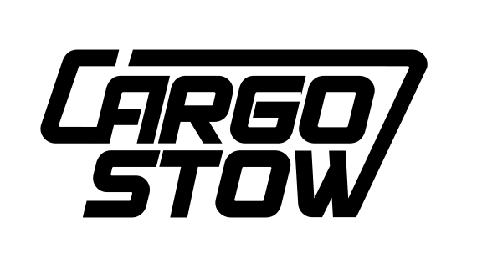

FOR IMMEDIATE RELEASE:

X-MODULE storage unit for pickup trucks

Johannes Huth, one of the founders of cargo-stow, lives in Lungau and spends a good amount of time there hunting. Together with his partner Steve Smith, he developed a modular system for pickups which the two founders now manufacture in the province of Salzburg. This system ensures that the various items needed for hunting are safely stored away and easily available. "Since we attach great importance to quality," says Huth, "only a medium-sized, highly qualified local company was an option for us. We have now found a local partner to produce the X-MODULE for us, available immediately for all pickup models.”

With the X- Module hunting box, which was initially developed for the new Mercedes X -Class, a hunter has sufficient storage space, an integrated winch, LED lighting, a 40-liter fresh water tank with electric pump, a heated dog box, a lockable rifle compartment and a fold-out writing desk.

cargo-stow presents the X- MODULE at the Hohe Jagd in Salzburg.

Multi-function boxes for the Ford Ranger, Toyota Hilux and other popular pickups are in development.

Contact:

cargo-stow GbR
Wilhelmstrasse 28
D-53111 Bonn
www.cargo-stow.com
email: j.huth@cargo-stow.com

